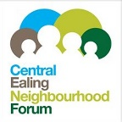
London Councils slow to back localism
Action needed to restore trust, Forum AGM told
Councils in London appear to be reluctant to give neighbourhood planning the support they are meant to under the Localism Act, showing far lower enthusiasm than in the shire counties, says Graham Pycock, Visiting lecturer, University of Westminster Business School, and Convenor, Neighbourhood Planners London.
Speaking at the Central Ealing Neighbourhood Forum AGM at the end of June, Mr Pycock said that Localism was meant to allow communities to have more control over the scale, location and design of new developments in their areas. While there has been some improvement on the often dubious "consultation" carried out in the past by local councils, more engagement by local people in planning is still needed to restore trust in local politics.
The establishment of smaller community councils, which are likely to be political but non-partisan, may be a logical next step, he concluded.
July 2019

