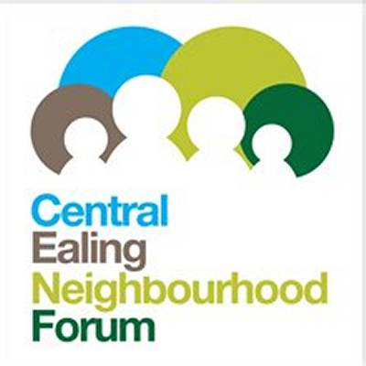
Central Ealing Neighbourhood Development Plan (CENDP) Referendum Area
Submission to the Examiner by the Central Ealing Neighbourhood Forum
(the ‘qualifying body’)
Introduction.
This paper examines the options for the area for the CENDP referendum. As there are several choices other than keeping just to the central neighbourhood area, it seemed appropriate to the Forum that it and the local planning authority (the London Borough of Ealing (LBE)) should seek to agree a position to put to the Examiner. However LBE believes there is no case for any wider area and accordingly this report and recommendation are those of the Forum alone. Its conclusion is that an area should be used which incorporates all of the electoral wards which are partly included in the neighbourhood area (Option 1 below). Arguments for and against some of the other choices are also set out below.
Background
Responsibility for setting the boundaries of the CENP referendum area lies ultimately with LBE. The detailed process is laid down in Schedule 4B to the Town and Country Planning Act 1990 (as inserted by Schedule 9 of the Localism Act 2011). The relevant paragraphs are copied below (Appendix A), but basically they provide that the local authority decides the area, after the independent Examiner has made a recommendation in the required report.
There is little guidance on how the Examiner’s initial assessment should be made, but the DCLG Planning Practice Guidelines on the Independent Examination (Paragraph: 059 Reference ID: 41-059-20140306) say:
“It may be appropriate to extend the referendum area beyond the neighbourhood area, for example where the scale or nature of the proposals in the draft neighbourhood plan or Order are such that they will have a substantial, direct and demonstrable impact beyond the neighbourhood area.”
There are few precedents for how Examiners have applied those tests in reaching their decisions, but a significant one is that of the report on the Central Milton Keynes plan (also a ‘business area’ for the purposes of neighbourhood planning). Here the Examiner concluded that the referendums should include the whole population of the borough (some 250,000 individual voters), and not merely the 3,000 people living in the central area covered by the plan. The relevant paragraphs from the Examiner’s report are set out below (Appendix B).
The Tests
The most significant consideration is whether the plan proposals “have a substantial, direct and demonstrable impact beyond the neighbourhood area.” While this is given as an example and would not rule out administrative convenience and cost as possible factors, the latter are unlikely to carry as much weight. However the balance of argument must rest on the local circumstances. These include:
- Character of the Neighbourhood Area
- Proximity of other centres
- Economic impact of plan proposals
- Other plan impacts
The Central Ealing Neighbourhood Area (CENA)
The CENA boundary largely follows that of the eastern end of the Ealing Metropolitan Town Centre (which is also that of the Ealing Broadway BID). It is a mainly a commercial area comprising retail and business premises, though with an expanding residential population. It is made up of sections of three LBE electoral wards (Ealing Broadway, Ealing Common and Walpole), and contains parts of 10 Polling Districts. In addition there is a tiny part of Hanger Hill ward inside the CENA which contains two residential and two business addresses. The current electoral roll (October 2016) shows less than 2,000 residents, registered as voters in 1,000 properties. The size of the segments in each PD varies considerably, both in number and as a proportion of the total electorate, as in Table 1 below:

Table 1
Voters in Neighbourhood Area and immediate vicinity
Col 1 | Col 2 | Col 3 | Col 4 | Col 5
Ward/Polling District | Total electorate | No of voters in NA | Col 3 as % of 2 | Col 3 as % of NA
Ealing Broadway
HAA | 1342 | 145 | 10.8% | 8.4%
HBA | 1998 | 76 | 3.8% | 4.4%
HCN | 1600 | 79 | 4.9% | 4.6%
HES | 1135 | 278 | 24.5% | 16.1%
HFS | 1810 | 711 | 39.3% | 41.3%
Total | 7885 | 1289 | 16.3% | 74.8%
Ealing Common
ECA | 2383 | 117 | 4.9% | 6.8%
EF | 1516 | 91 | 6.0% | 5.3%
Total | 3899 | 208 | 5.3% | 12.1%
Walpole
VA | 2146 | 184 | 8.6% | 10.7%
VB | 1327 | 40 | 3.0% | 2.3%
Total | 3473 | 224 | 6.4% | 13.0%
Hanger Hill
FGA | 1252 | 1 | 0.2% | 0.1%
Total | 1252 | 1 | 0.2% | 0.1%
Total all | 16509 | 1722 | 10.4% | 100.0%

The initial CENF public consultation in summer 2013 covered the wider area (Table 1 Col 2), which then contained about 16,000 voters at 8,800 separate addresses. This ‘consultation area’ was chosen as it was defined by complete polling districts forming a ring around the town, the boundaries of which are about 1 to 1½ miles (1.5 to 2 km) from the centre (defined as the Town Hall). It is also primarily residential, and looks to Ealing Broadway for much of its local shopping needs.

Proximity of other centres
Outside the 1½ mile radius there are secondary shopping areas serving local shoppers and several out-of-centre supermarkets, at a distance of between 2 to 2½ miles (3 to 4km). Major competing centres (including other metropolitan town centres) exist in a 5 mile (8 km) radius (CENP map 1).
Economic impact of plan proposals
By definition CENP does not deal with strategic issues such as transport. Its main purpose is to identify the special characteristics of the town centre and propose policies to protect and develop these in the face of competitive pressures. The main economic objectives concern the viability and vitality of the town as a commercial centre.
Other impacts
A major concern of those consulted in the early stages of the plan development was the need for adequate social infrastructure to support the large planned increase in population in the town centre in the lifetime of the borough plan. Much of this provision (eg schools and health services) falls outside the scope of the neighbourhood plan, but spatial provision in mixed-use development is relevant, as is availability of facilities for cultural activities and entertainment. The main impact of such facilities falls on those in the immediate vicinity and within easy reach of the centre.
Elements of CENP which have a wider impact mainly concern proposals for cultural facilities aimed at achieving its Vision of Ealing as a regional centre of excellence for culture and education.
CENP is not considered to have an environmental impact beyond its immediate vicinity.
Other considerations
Electoral divisions. A significant problem with restricting the referendum vote just to the Neighbourhood Area is that, as shown in Table 1, it does not coincide with existing polling districts (PDs). Regulations require that a referendum has to follow existing voting arrangements. If the smaller area is chosen, this would necessitate preparation of special electoral registers for every existing PD and the provision of a full polling station at the normal location for each PD in which there were eligible voters. All 10 areas would therefore have to have fully manned stations all day, even if no-one actually voted in that district. This would be at a significantly high cost per voter, with little benefit when compared to setting the boundaries to incorporate full PDs.
It should be noted that PDs are more likely to represent natural geographical areas with their own characteristics than the larger electoral wards which have been put together largely for reasons of meeting electoral quotas. Though in an urban area this is also very slight, they are more likely have some feeling of community identity, and form better units for assembling a local referendum area.
Area relevance. Ealing is often divided into broad areas corresponding to the communities which form the London borough, as for example health administration. Ealing’s widely recognised neighbourhood areas, ie. Acton, Ealing, Hanwell, Greenford, Northolt, Perivale and Southall, also largely retain their original centres and identities. The Ealing Metropolitan Centre is itself divided into two, with the western part about to submit its own neighbourhood plan (West Ealing Town Centre NP). Two further areas (Acton and Hanwell) are at earlier stages of plan development.
Cost. A further consideration is the size of any electorate outside the immediate neighbourhood area which it should be considered reasonable for a neighbourhood forum to have to reach in publicising its plan, to ensure a reasonable level of voter turnout and support. CENF has no resources of its own for this, and could not expect any significant contribution from the original stakeholders such a residents’ associations or Make It Ealing (the name of the Ealing Broadway BID company).
Alternative referendum area boundaries
Other than the neighbourhood area itself, options for the referendum area could be:
- The original ‘consultation area’ as defined in the plan (Table 1 Col 3).
- The entire borough of Ealing.
- All wards on the outskirts of the broad Ealing administrative area (Table 2 below)
- The whole of the electoral wards in which the PDs in Option 1 fall (Table 1 Col 2)
A map showing the neighbourhood area and the relevant electoral wards is attached. The table below shows the number of registered voters in each of the wards concerned.
Table 2
Voters in full wards
Ward | Total electorate
Wards including part of CENA
Ealing Broadway | 10799
Ealing Common | 10547
Walpole | 9960
Hanger Hill | 10822
Total | 42128
Other Ealing wards
Cleveland | 10791
Northfield | 10179
Total | 20970
Total all | 63098

Consideration of options
Option 1 This option avoids the logistical difficulties of restricting the referendum to the neighbourhood area, which as noted is administratively difficult and unnecessarily costly. Residential areas close to the centre are the ones most likely to be significantly impacted by the plan proposals. In the case of Hanger Hill FGA PD, it would also be hard to justify denying a vote for anyone within the area, even if it were only one person or business, so this would be included.
Opition2 Although it could be argued that there will be some impact across the entire borough, this will be largely indirect. It has therefore been discounted as going far beyond the area where CENP could be considered as having ‘a substantial, direct and demonstrable impact’.
Option 3 The peripheral Ealing wards of Cleveland and Northfield do not seem to qualify under the same test. Cleveland is more likely to be orientated towards West Ealing, while Northfield has its own quite substantial local shopping frontages, as well as being on the east-west underground service. There have been virtually no responses from these two areas to the public consultations.
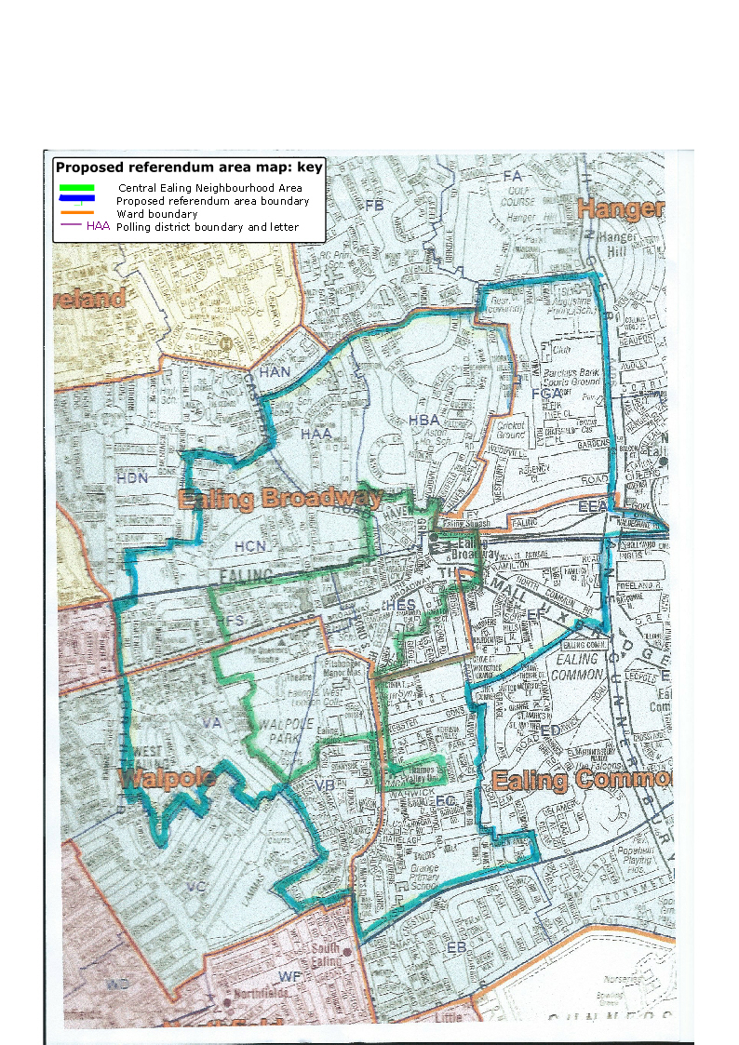
Option 4 The remaining option incorporates a wider band around the centre than Option 1, with residential properties which will see much less direct impact from the plan. It also adds some businesses north of the A40 which have little or no connection with the centre. The option is not any simpler administratively. Excluding these PDs, which are further away and which do not appear to meet the suggested test, is more justifiable
On the balance of arguments the Forum management committee agreed to recommend Option 1.
Map: Proposed referendum area

CENP Referendum Area boundaries
25 Nov 16

Appendix A
Schedule 4B to the Town and Country Planning Act 1990 (as inserted by Schedule 9 of the Localism Act 2011) provides inter alia that:
8(1) The examiner must consider ……………
(d) whether the area for any referendum should extend beyond the neighbourhood area to which the draft order relates…..
10(5) If the report recommends that an order (with or without modifications) is submitted to a referendum, the report must also make—
(a) a recommendation as to whether the area for the referendum should extend beyond the neighbourhood area to which the order relates, and
(b) if a recommendation is made for an extended area, a recommendation as to what the extended area should be.
Consideration by authority of recommendations made by examiner etc
12(1) This paragraph applies if an examiner has made a report under paragraph 10.
(2)The local planning authority must—
(a) consider each of the recommendations made by the report (and the reasons for them), and
(b) decide what action to take in response to each recommendation.
……………
(8) If the authority consider it appropriate to do so, they may extend the area in which the referendum is (or referendums are) to take place to include other areas (whether or not those areas fall wholly or partly outside the authority’s area).
(9)If the authority decide to extend the area in which the referendum is (or referendums are) to take place, they must publish a map of that area.

There are no further Regulations which guide the Examiner

Appendix B
Report of the Examiner to Central Milton Keynes Town Council of the Examination into the Central Milton Keynes Alliance Neighbourhood Plan (extract).
14.4 Referendum Area
14.5 It is the independent examiner’s role to consider the referendum area appropriate in the event that the Qualifying Body wishes to proceed to the referendum stage. As the CMKAP is a Business Neighbourhood Plan, two referendums will be required; one comprising those persons with a vote in local elections and with a qualifying address is in the referendum area, the other a business based referendum in which those entitled to vote are non-domestic ratepayers in the referendum area. The provisions of the Neighbourhood Planning (Referendums) (Amendment) Regulations 2013, which came into force on 6th April 2013 set out the process and procedure. The referendum areas are to be identical and must as a minimum comprise the neighbourhood plan area.
14.6 In the case of the representations made during the consultation period, all of the respondents who commented on the matter of referendums in the event that the Plan went forward to the referendum stage, sought that the area of the referendum should extend to the Milton Keynes Borough Council administrative area. This is an entirely reasonable expectation as the CMK retail, leisure and employment uses benefit not only the small current resident population of about 3,000, based within the neighbourhood plan area, but the 250,000 individuals, or thereabouts comprising the resident population of the Borough. Borough-wide referendums, should these endorse the Plan, will increase the legitimacy of the Plan and on the basis that support is given, such endorsement should encourage greater community cohesiveness and a shared ambition to secure and deliver the objectives of the Plan.
14.7 The consultation responses referred to the democratic need to consult widely on the Plan which will shape the future character of Central Milton Keynes. A keen sense of ownership of CMK was expressed by a number of respondents.
14.8 To the extent that the residential and business referendum areas must be identical to comply with the regulations. As I consider that it is appropriate for the residential referendum to be Borough-wide, for sound reasons of democracy and equity, it follows that this geographic area must apply to the business referendum. There is no opportunity for the examiner to specify different referendum areas under the regulations.
14.9 I therefore recommend that if referendums are to be held, that the geographic extent of each should extend to the administrative boundary of Milton Keynes Council.

