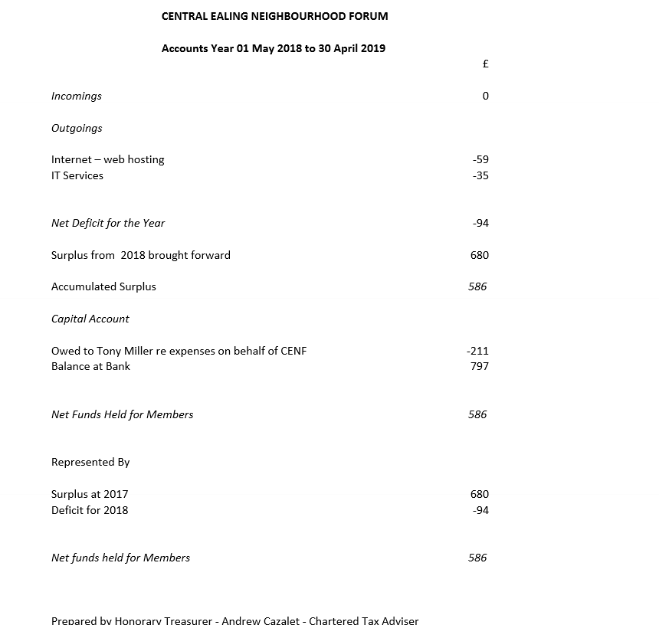
Approved by the committee subject to examination, 25 June 2019

